Here is my original description of the method for doing it. I have added a couple of things since first posted. Feel free to put it in the format that works best on your site:
Sometimes a "step by step" says it best. You can make fldigi run in multiple "instances" - at the same time. Only one copy of fldigi.exe needs to be on your computer. My situation: I use both a 7300 and a 705 on digital and I have multiple fldigi instances configured that I can use just for the rigs I want to use. I can also set up multiple instances of fldigi to talk to one instance of flrig with a few more steps. I will only cover the basics in this "How To".
Setting up multiple instances of fldigi in Windows. The icon method.
Why does this work and how? >>> fldigi can create a new configuration directory if you add a bit to the target line in the icon or in a command line. For each instance you can customize for the purpose you want without copying the fldigi .exe file or the main install directory. This description only addresses the "Icon Method".
After installing fldigi the first time, run it and do a basic configuration, then close the program. Next:
1. Copy your fldigi icon.
2. Paste two or more copies onto the desktop. Rename each icon to something that will help you remember what rig it is listening to like:
"Fldigi 4.2.06.24 IC-7300A" and "Fldigi 4.2.06.24 IC-705A" for example
3. Open the first icon copy properties settings by right clicking the icon and selecting Properties.
4. You will see something that looks like this:
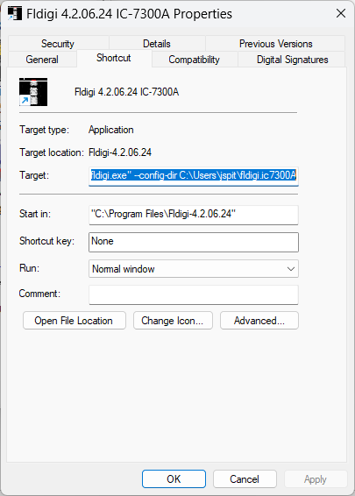
5. Add something like this to the end of the Target line: --config-dir C:\Users\"your username"\fldigi.ic7300A so the whole line reads:
"C:\Program Files (x86)\fldigi-4.2.06.24\fldigi.exe" --config-dir C:\Users\"your username"\fldigi.ic7300A
- You should change "your username" bit to your actual username (if you don't know it, you can find it on your log in panel or by going to the C:\Users directory and looking at the filename there. I like to use the model number of your rig like"ts590A" or "ft818A" so you know what rig you're configuring. I use the A, B, etc because I often run more than one instance per rig.
- My full Target line looks like this: "C:\Program Files (x86)\fldigi-4.2.06.24\fldigi.exe" --config-dir C:\Users\jspitzn\fldigi.ic7300A
NOTE: make sure you use -- (dash dash) before "config-dir" or just copy and past the line then edit it for your needs.
6. Click on Apply at the bottom of the panel. Then close the panel by clicking "OK".
Repeat the steps above for the second copy of the icon - in my case that would be for my ic705 so the Target line would look like:
"C:\Program Files (x86)\fldigi-4.2.06.24\fldigi.exe" --config-dir C:\Users\jspitzn\fldigi.ic705
When you double click on each of the new icon copies, a new config directory is created and you will be asked to configure fldigi like you would for a new install. Go through the configuration to customize fldigi to behave as you wish it to.
I don't advise you copy your original config directory at first! >>>However: If you want to start with the same settings that you have for your original instance of fldigi, you will need to copy the entire original default config directory into the new config directory. This can create some other issues for first time multi-instance users that I don't want to discuss in this email.
Good luck!
Jack Spitznagel
KD4IZ FM19oo
Parkton, MD

